13. Perform Affine Transformation on an Image Using Python and OpenCV
Aim
To perform an affine transformation on an image using Python and OpenCV.
Procedure
- Import the OpenCV and NumPy libraries.
- Read the input image.
- Select three points from the original image.
- Define three corresponding points for the transformed image.
- Apply affine transformation using cv2.getAffineTransform() and cv2.warpAffine().
- Display the original and transformed images.
Program

import cv2
import numpy as np

img = cv2.imread("sample.jpg")

rows, cols = img.shape[:2]

pts1 = np.float32([[50, 50], [200, 50], [50, 200]])
pts2 = np.float32([[10, 100], [200, 50], [100, 250]])

matrix = cv2.getAffineTransform(pts1, pts2)
result = cv2.warpAffine(img, matrix, (cols, rows))

cv2.imshow("Original Image", img)
cv2.imshow("Affine Transformation", result)

cv2.waitKey(0)
cv2.destroyAllWindows()
Input
An image named sample.jpg stored in the same folder as the Python program.
Output

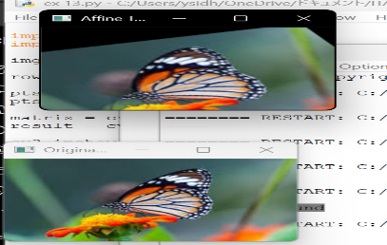
- Original image
- Affine-transformed image
Result
Thus, affine transformation was successfully performed on the given image using Python and OpenCV.

